**Sequence Diagram:**

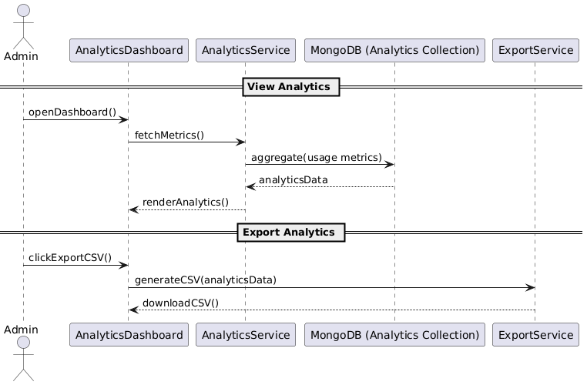

**State Diagram**

**Class Diagram**

**ERD**

**Functional Requirements**

1. System should collect and store platform usage metrics (logins, posts, reports, violations).
2. Admins can view aggregated data in charts (daily, weekly, monthly).
3. Support filters for analytics by date range, user role, post type, etc.
4. Analytics dashboard updates periodically (e.g., every 5 mins).
5. Admins can export analytics data to CSV.
6. Metrics include: number of new users, number of reports, violations resolved, active users.

**Non-Functional Requirements**

1. Analytics should not degrade performance of main system (async or background jobs).
2. Charts must render within 2 seconds for up to 10,000 records.
3. Ensure accurate aggregation (no double counting).
4. System should handle real-time updates without full page reload.
5. Data should be cached and refreshed every 5 mins.